DESIGN TASK
M Jeevitha
(192424257)
1. A healthcare organization has collected patient waiting-time data from 20 hospitals over one year.
Task: Design a visualization dashboard that:
● Shows Box Plots and Violin Plots for waiting times across hospitals.
● Identifies outliers and extreme waiting-time cases.
● Highlights differences in median waiting times and variability among hospitals.
Objective: Help hospital administrators identify service inefficiencies and improve patient care quality.
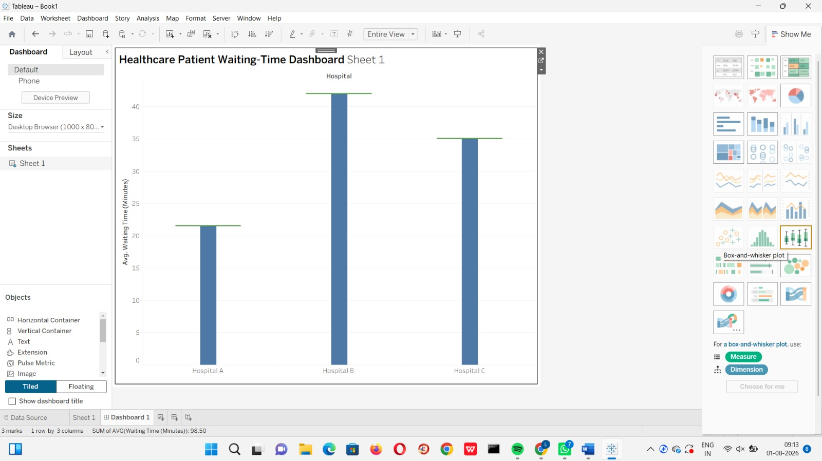
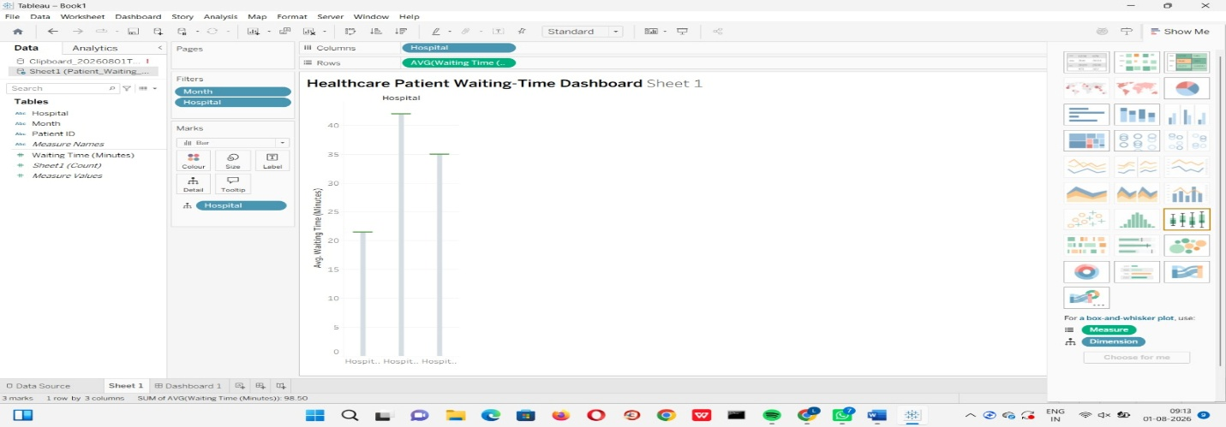
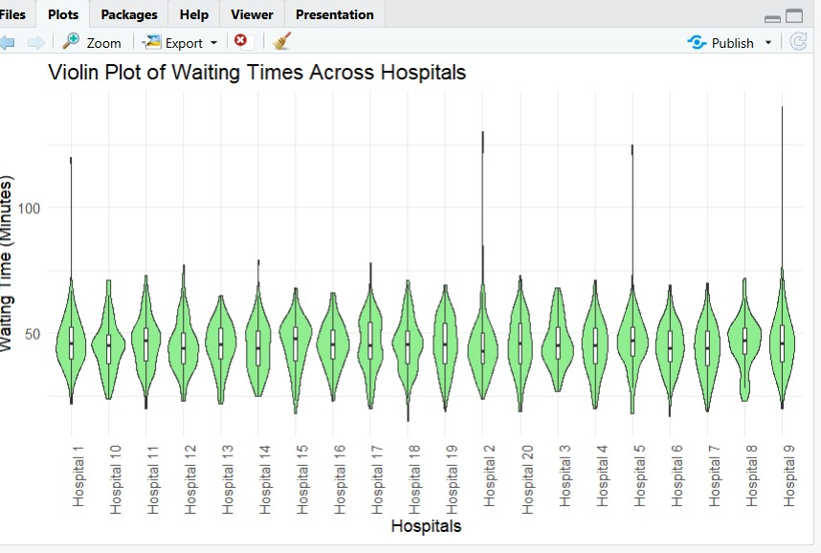

2. A smart city project monitors hourly air quality data (PM2.5, PM10, NO₂, and CO) from 15 monitoring stations.
Task: Create a visualization design that:
● Uses Heatmaps to display pollution intensity across locations and time periods.
● Employs Ridgeline Plots to compare pollutant distributions among stations.
● Highlights pollution spikes and abnormal environmental conditions.
Objective: Assist environmental authorities in identifying pollution hotspots and planning mitigation measures.
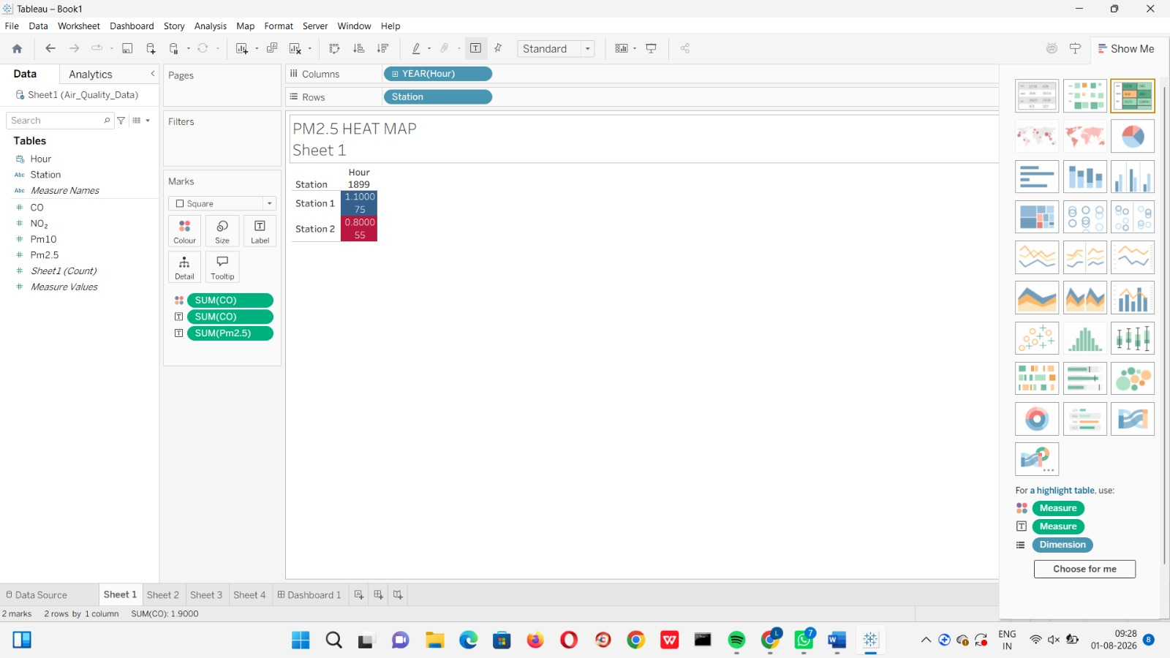

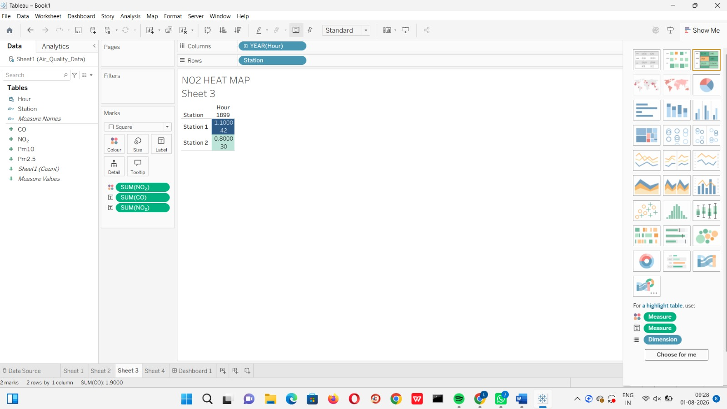

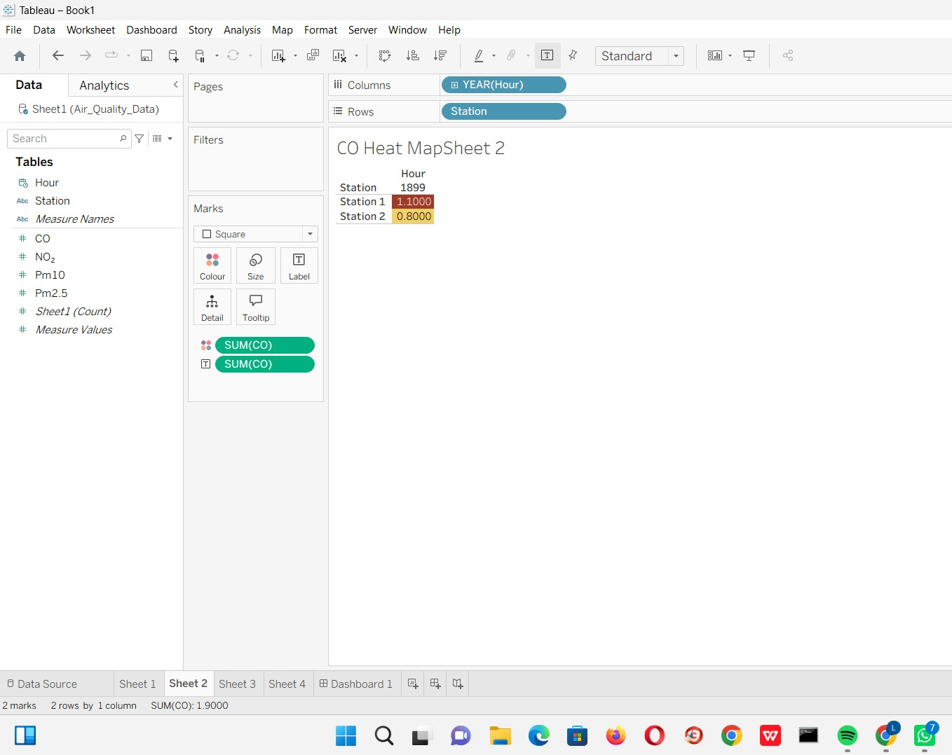
3. A university tracks student academic performance across multiple departments over five academic years.
Task: Design a visualization dashboard that:
● Uses Line Charts to show performance trends over time.
● Incorporates Scatter Plots to analyze the relationship between attendance and grades.
● Uses Facet Grids to compare departmental performance simultaneously.
Objective: Enable academic administrators to identify performance trends and factors affecting student success.
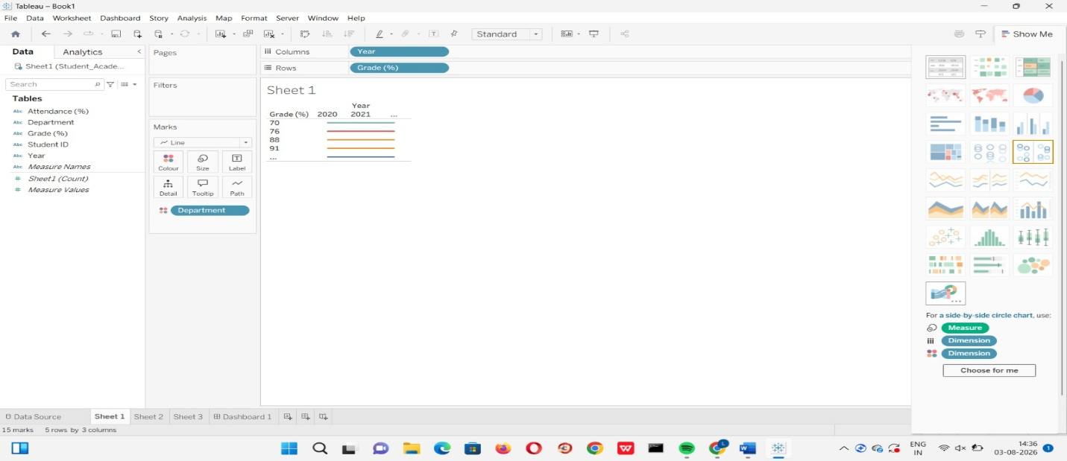

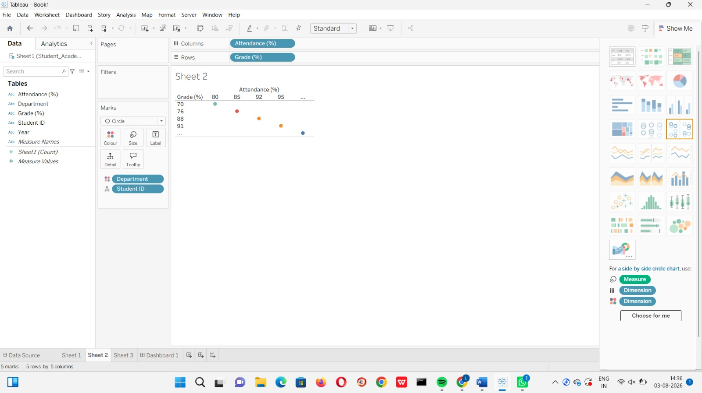

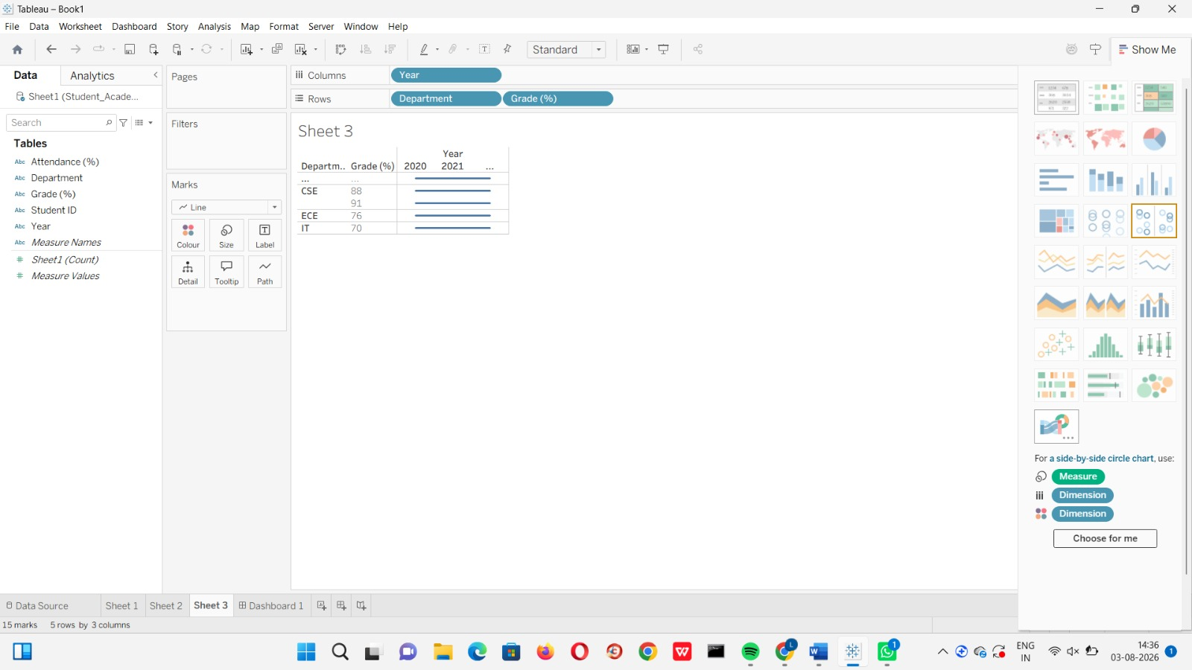

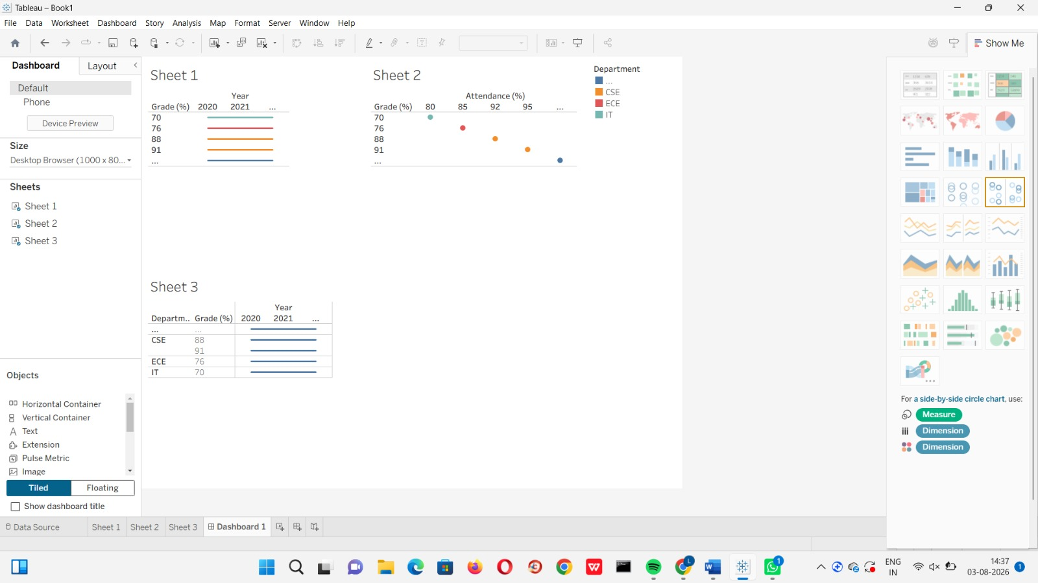
4. A logistics company records delivery times for thousands of shipments using Road, Rail, Air, and Sea transportation modes.
Task: Create a visualization design that:
● Uses Histograms and ECDFs to compare delivery-time distributions across transportation modes.
● Employs Q-Q Plots to assess whether delivery times follow a theoretical normal distribution.
● Highlights delays, variability, and outliers in delivery performanceObjective: Support operational teams in optimizing transportation strategies and improving delivery reliability

